September 28, 1917
The Significance of Pilgrimage and Sacrifice in Islam:
I bear witness that none deserves to be served besides Allah and I bear witness that Muhammad is the servant and messenger of Allah.
After this, I seek the protection of Allah from the accursed devil.
In the name of Allah, the Beneficent, the Merciful.
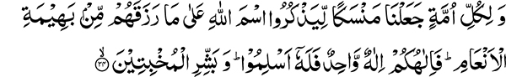
And for every nation We appointed acts of devotion that they might mention the name of Allah on what He has given them of the cattle quadrupeds. So your God is One God, therefore to Him should you submit. And give good news to the humble, (22:34)
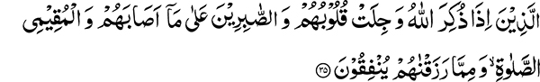
Whose hearts tremble when Allah is mentioned, and who are patient in their afflictions, and who keep up prayer, and spend of what We have given them. (22:35)
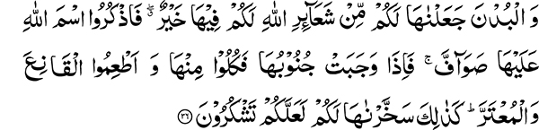
And the camels, We have made them of the signs appointed by Allah for you — for you therein is much good. So mention the name of Allah on them standing in a row. Then when they fall down on their sides, eat of them and feed the contented one and the beggar. Thus have We made them subservient to you that you may be grateful. (22:36)
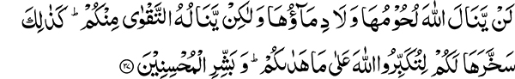
Not their flesh, nor their blood, reaches Allah, but to Him is acceptable observance of duty on your part. Thus has He made them subservient to you, that you may magnify Allah for guiding you aright. And give good news to those who do good (to others). (22:37)
Unfounded criticism of Sacrifice in Islam
The sacrifice of an animal during Eid-ul-Adha has been the object of unfounded criticism by opponents of Islam. Objection is raised that since slaughter of animals is called one of the signs of Allah, it somehow indicates lack of compassion in Islam. If, however, we study the dietary habits of humans from a historical and evolutionary perspective it becomes quite apparent that animal protein has always been one of the components of the human food chain. Therefore, forbidding it on the basis that an animal loses its life in the process is not a valid argument.
Putting aside the objection that animal sacrifice amounts to cruelty to animal, we need to see, what is the purpose of sacrificing on this particular occasion? This section of the Holy Quran provides us with the answer. Before these verses mention is made of the Pilgrimage that actually answers these objections. The Holy Quran tells us:
And for every nation We appointed acts of devotion.
Islam provides us with amazing arguments and proofs. For example the verse regarding fasting:
O you who believe, fasting is prescribed for you, as it was prescribed for those before you, so that you may guard against evil. (2:183)
This verse answers the objection of Christian critics: The history of various nations bears witness to the fact that principle of fasting exists in some form or other amongst all nations. Those objecting to animal sacrifice should ponder. This principle is also found in the religious observances of all nations including the sacred book of Hinduism, the Vedas. It is surprising that they now raise objections against what exists within their own religion. There criticism becomes invalid since the institution exists among all nations.
Purpose of Sacrifice in Islam
Every principle that Islam has adapted has truth within it. Previous nations performed sacrifice to atone for their sins. Such commandment does exist in the Torah, the Scripture of the Jews. Only Allah knows if this was essential for the early developmental stages of man or was added later on. Islam, however, does not link sacrifice with expatiation of sins. The Holy Quran states:
Allah accepts only from the dutiful. (5:27)
This verse points out that sacrifice strengthens the bond between God and the righteous as a sign from Him and not for the atonement of sins.
Pilgrimage and complete equality of the human race
Pilgrimage is yet another principle of Islam. What do we observe during Pilgrimage? The king and the beggar are all dressed alike. What does this show? It is a demonstration that all are equal before God. The rich do not have precedence over the poor. The rich man sleeping in his comfortable warm bed and the poor man freezing in the cold are all alike before Him. Pilgrimage (Hajj) is a sign to demonstrate this equality so that people should know and witness this scene with their own eyes. Unlike the verbal description a condition that one actually experiences has a profound effect upon the heart. The decree is not to use sheets sewn together to cover the body. Unsown material is used because distinctions can be created by the process of sewing. The rich would then be wearing distinctive materials highlighted by the needlework. Right now when Eid ul Adha is being celebrated all over the world, people performing the Pilgrimage would also be making the sacrifice and the equality amongst all is thus uniformly maintained for these few days. The idea is to touch the human heart and soul.
There is a certain degree of equality also manifested in the obligatory prayer service. The poor man in his tattered clothing and the rich in his expensive dress are standing shoulder to shoulder in front of God. The rich might try to distinguish themselves here but in the Pilgrimage complete equality is maintained. Beholding this scene the pilgrim is reminded of the day of resurrection. Sacrifice of the animal with one’s own hands also leaves an impression. It has a profound effect upon the heart. Such feelings do not arise in the hearts of professionals who do this for a living. There is a sign in this from God. Just as the animals have been given under our control, God has control over us. Just as the animals put their lives in your hands, you should be ready to sacrifice your life to uphold the Truth.
War and Sacrifice
These verses are followed by the commandments regarding defensive warfare. Both these commandments have in a way been linked together. Be prepared to lay down your life to uphold the truth. Progress in the path of human spiritual development depends upon sacrifice. Sacrifice means giving up one’s wealth, power and dignity to serve someone without any personal motive. This is the true spirit of sacrifice and selflessness!
An individual cannot make progress by himself. He has to associate with someone for this purpose. For example in marriage one has to look after all the needs of his spouse, this is a form of sacrifice. Above and beyond this is the sacrifice of the individuals for their nation. The progress of a nation depends also upon the sacrifice of individuals laying down their lives for a national cause. This shows that just as sacrifice is needed for the nation, an even higher level of sacrifice is needed to serve God. God the Most High does not benefit from this, in fact it benefits His creation, as affirmed by the Quranic verse:
Say: My prayer and my sacrifice and my life and my death are surely for Allah, the Lord of the worlds— (6:162)
A Muslim is therefore told to make sacrifice for God in order to serve His creation. Kings sacrifice their lives because of their faith in their power and resources. What was the source of strength for the Companions of the Holy Prophet? They were few individuals without any worldly resources. That was the reason the Hypocrites did not join with them to defend Islam and Muslims against a powerful enemy bent upon their extirpation. They would relinquish their support by saying:
We fear lest a calamity should befall us. (5:52)
The Companions of the Holy Prophet fought for:
The Lord (Nurturer unto Perfection) of the worlds (all creation).
We observe that in spite of the far greater numerical and material strength of the enemy, they unhesitatingly submit before Allah’s command. There is no outward source of strength but only the Promise of God that you will be successful! Do not fear that you are few in numbers. We do not possess even one out of a thousand portions of the spiritual strength and the practical example manifested by the companions of the Holy Prophet. The honored companions may Allah be pleased with them prevailed with the message of Truth all over the world within a period of twenty one years. Look at yourself, what have you achieved in the last twenty years? The law of progress is the same for all. The difference is in the degree of sacrifice made by the noble companions of the Holy Prophet. Our sacrifice pales in comparison to theirs. The truth is that even few can make progress but not without making sacrifice. Similarly a nation cannot achieve greatness without making sacrifice.
Progress is not possible without Sacrifice
The Promised Messiah writes in his book, Tazkira-i-Shahadatain (Memoir of the Two Martyrdoms) that our progress is correlated to a period of three hundred years. This shows that our progress will take place not after a few but many years. This, however, should not be the reason to give up trying. Do not forget that the progress of your organization is dependent upon sacrifice. A solitary individual stands up in the land of the cross and makes a small sacrifice. See how much progress he made. Unless you do not face difficulties you cannot be strong. Even now there are kings (with material resources) amongst the Muslim nations, why is it that they do not make progress? It is because they do not commit their lives to face hardship. Belief in the Promised Messiah is not enough, we have to be ready to make sacrifice and face difficulties. The religion of the cross is making great progress because its adherents face great difficulties for their cause. The Holy Quran states:
And that man can have nothing but what he strives for:
And that his striving will soon be seen (53:39-40)
Even those with false beliefs who strive can achieve something.
Directive for charitable giving
You who have the truth with you, why is it that you are reluctant to face any difficulty? Holy Prophet Muhammad enjoined charitable giving on the occasion of Eid. I, in following the Holy Prophet’s tradition appeal before you to give in charity. It is a day for men and women to set an example by practice. Show readiness to face difficulties. Why did the Muslims invent some devotional rituals? Intent behind some of these was good. Regarding the followers of Christianity the Holy Quran states:
And (as for) monkery, they innovated it - We did not prescribe it to them-only to seek Allah’s pleasure (57:27)
Similarly some devotional practices were invented by Muslims to bear hardship in the way of God. They followed these when no other challenges were there. If someone’s heart does not perceive any difficulty at this time he should chose one to follow. The truth is that without sacrifice and facing difficulties progress cannot be made!

Section 4, Pilgrimage MMA English Translation and Commentary
See Khawaja Kamal-ud-din, History of the Woking Muslim Mission

